**How to use Metadata Maker**

Metadata Maker is a web application (<http://iisdev1.library.illinois.edu/marcmaker/>) that is used for creating *good enough* quality metadata in four different formats depending on the needs of the system to which the metadata will be ingested. This document is for anyone who wants to use the tool in metadata creation.

1. **Elements Supported in the Application**

The application supports the 17 elements as shown below. Among them, five elements are required: Title, Language, Number of Page, Dimensions, and Keyword.

|  |  |  |  |
| --- | --- | --- | --- |
| **Element Name** | **Required/Optional** | **Element Name** | **Required/Optional** |
| **Title** | Required | Date of publication | Optional |
| Subtitle | Optional | Copyright date | Optional |
| ISBN | Optional | **Number of pages (volumes)** | Required |
| Edition statement | Optional | **Dimensions** | Required |
| **Language** | Required | Literature | Optional |
| Author | Required if available | Illustration | Optional |
| Name of publisher | Optional | **Keywords** | Required |
| Place of publication | Optional | Note to the Cataloger | Optional |
| Country of publication | Optional |  |  |

1. **Adding Values**

* Each element has descriptive information (that is displayed when a user puts their cursor over the question mark beside the text box) to tell the user how the value for each element should be selected from the item and added into the box.

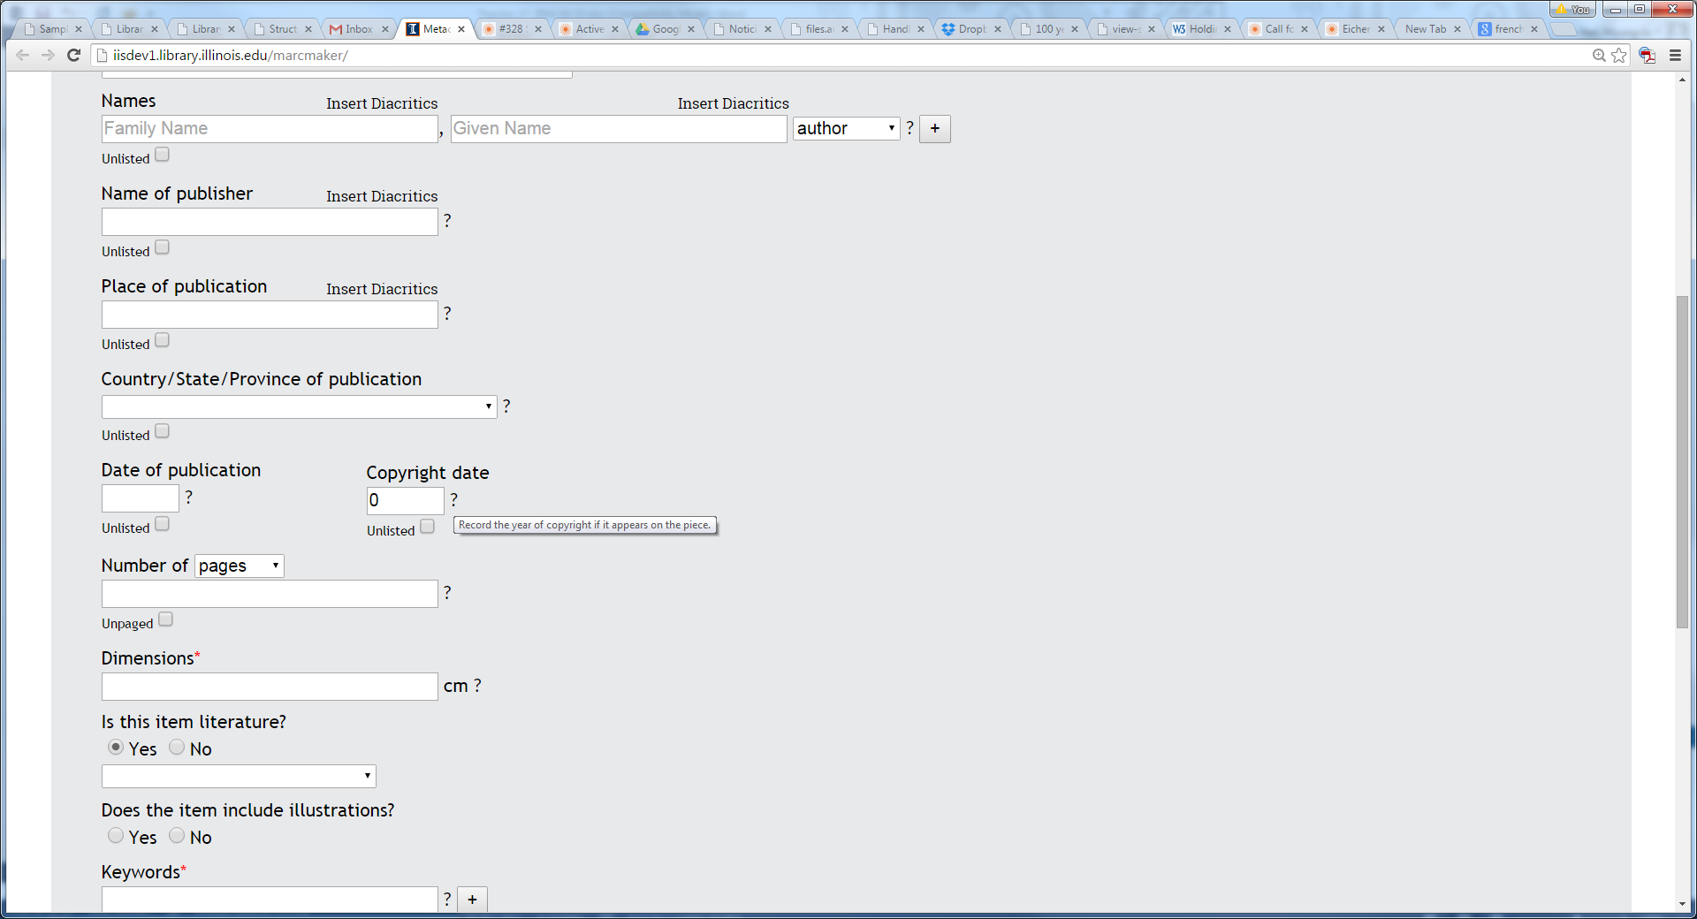

* All required elements are marked with a red asterisk. The application will give an error message at the end of the process if this information is not included.

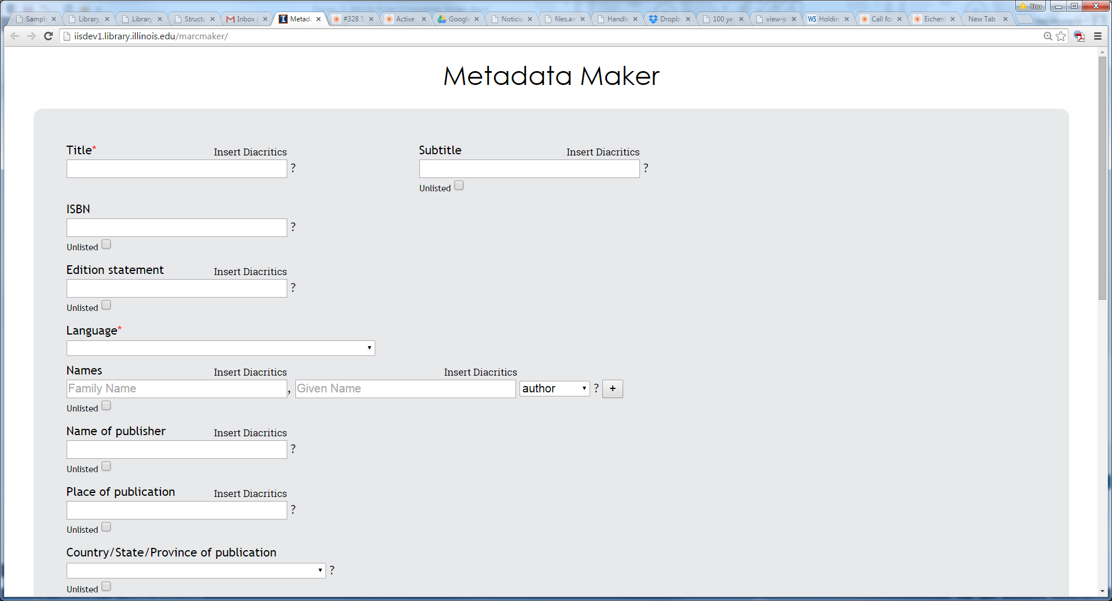

* For all optional elements, there is a box that says “Unlisted.” When there is no information available, this box should be checked, otherwise the application will give an error message at the end of the process.



* For names, a user can select the role of the person. For now, the application supports artist, author, contributor, editor, illustrator, and translator.



* Name and Keyword elements can be repeated whenever necessary. By clicking a plus sign, the user will create a new box.

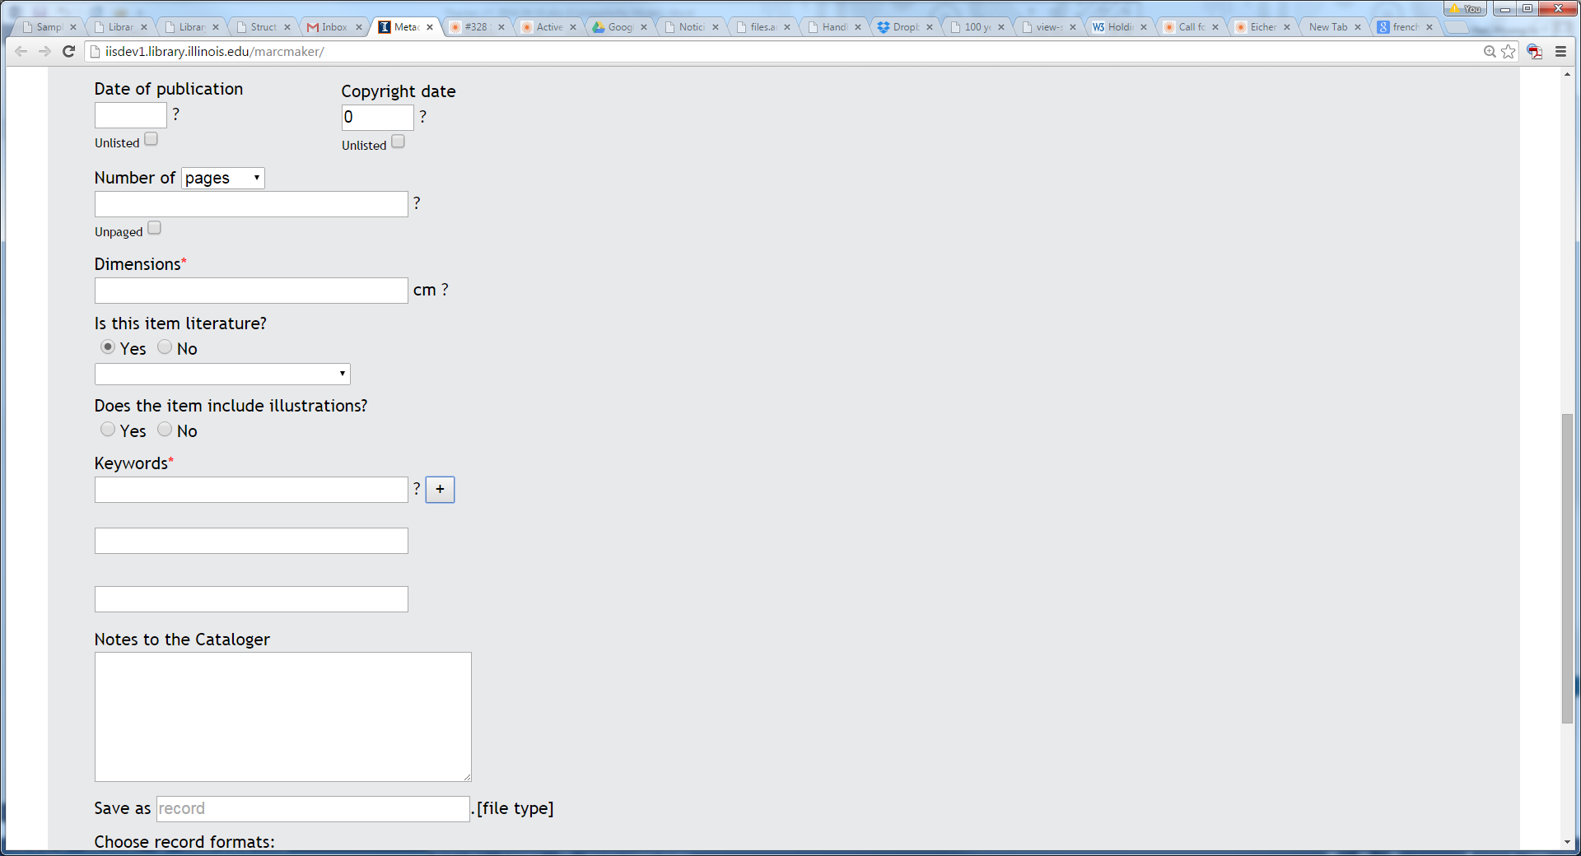

* Value for the Language, Place of Publication, Country/State/Province of publication, Date of publication, Copyright date, Keyword, and Literature type is selected from the values provided from the dropdown menu. Keyword uses the FAST headings. However, if there is no appropriate term available in FAST, a user can add any term they like. When the value is chosen from FAST, the FAST ID is also saved into the metadata as well as the string value.

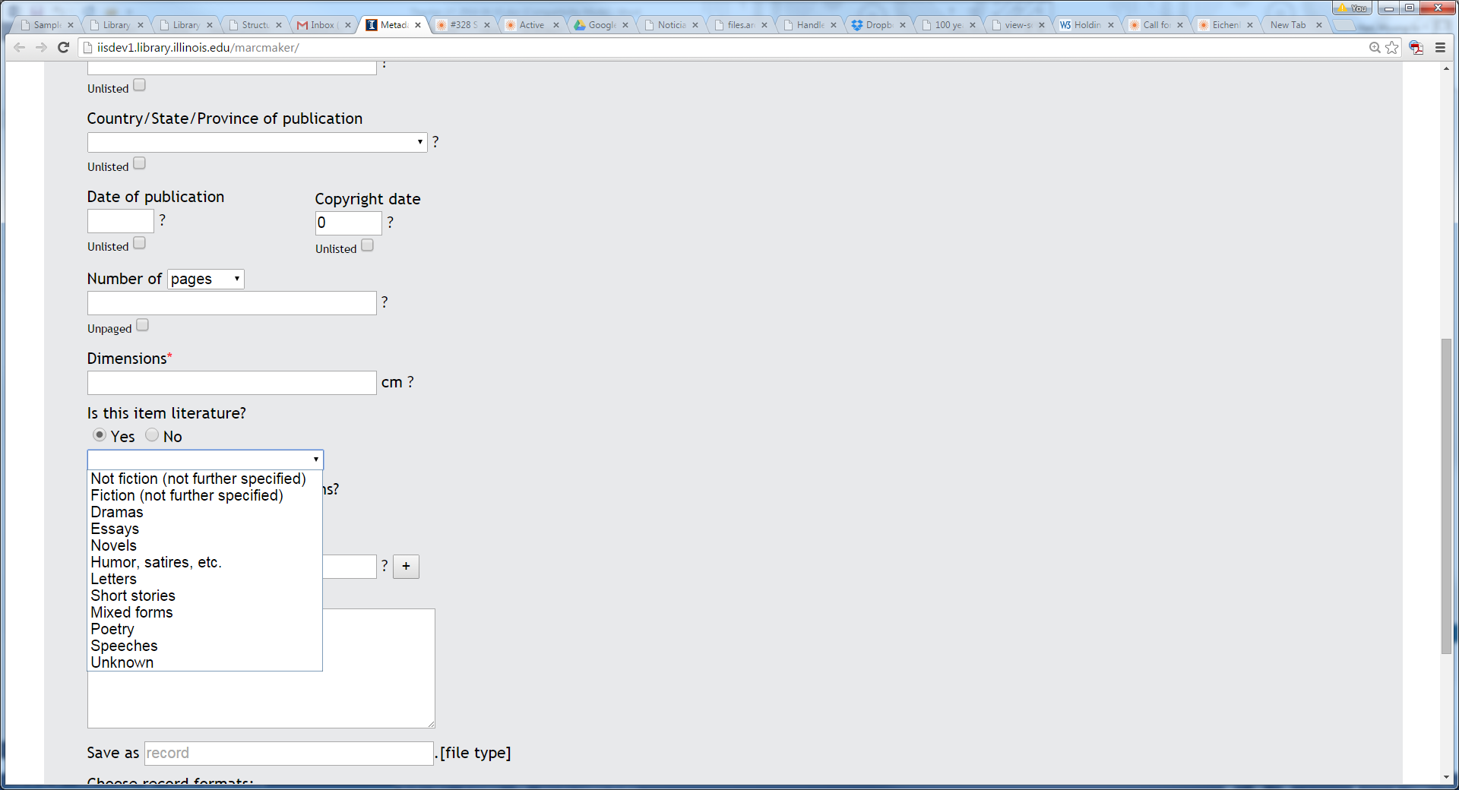 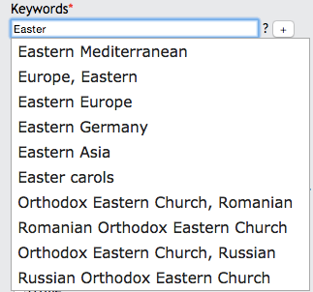

* Title, Subtitle, Edition statement, Names, Name of publisher, and Place of publication elements support the diacritics. Clicking the ‘Insert Diacritics’ causes the diacritics table to appear, and any character can be added by clicking the corresponding character box.

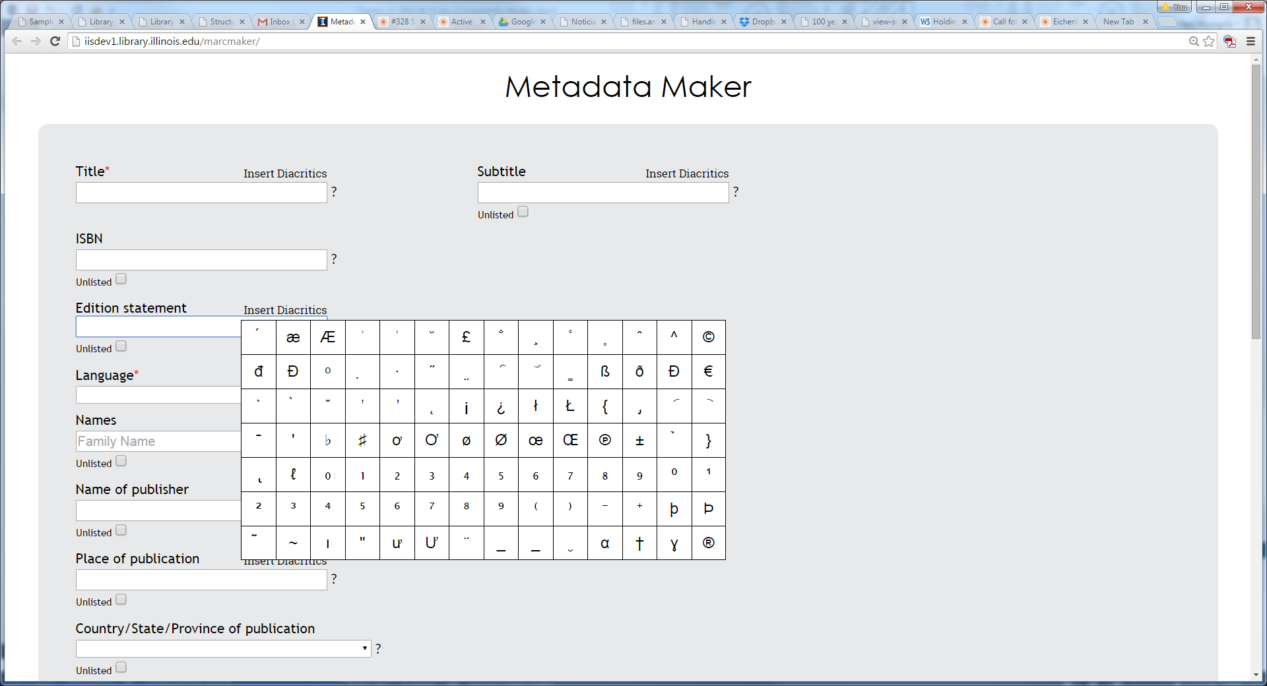

* Title, Subtitle, Edition statement, Names, Name of publisher, and Place of publication elements also support transliterated fields. When adding non-roman language characters, the application automatically shows the transliterated field. This information will be transformed into the appropriate metadata field.

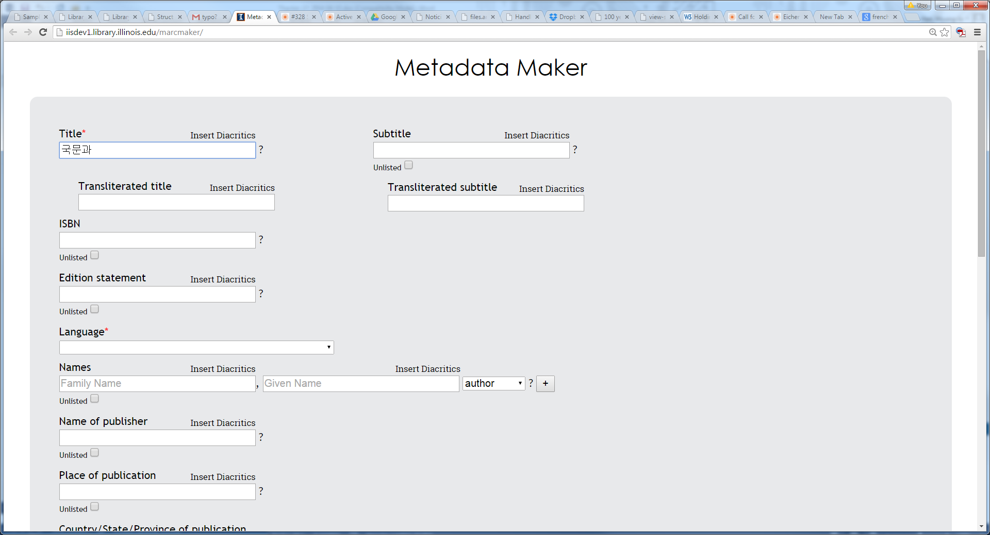

**3. Metadata File Creation**

* Metadata can be named as needed. If no name is given, the metadata will have ‘record’ as its name. File type will be determined by format. The output metadata type can be chosen by the user from four different types. By clicking the ‘Make’ button, the metadata of type(s) is saved into the user’s workstation. The application keeps the information added until the user clicks the ‘Clear’ button.

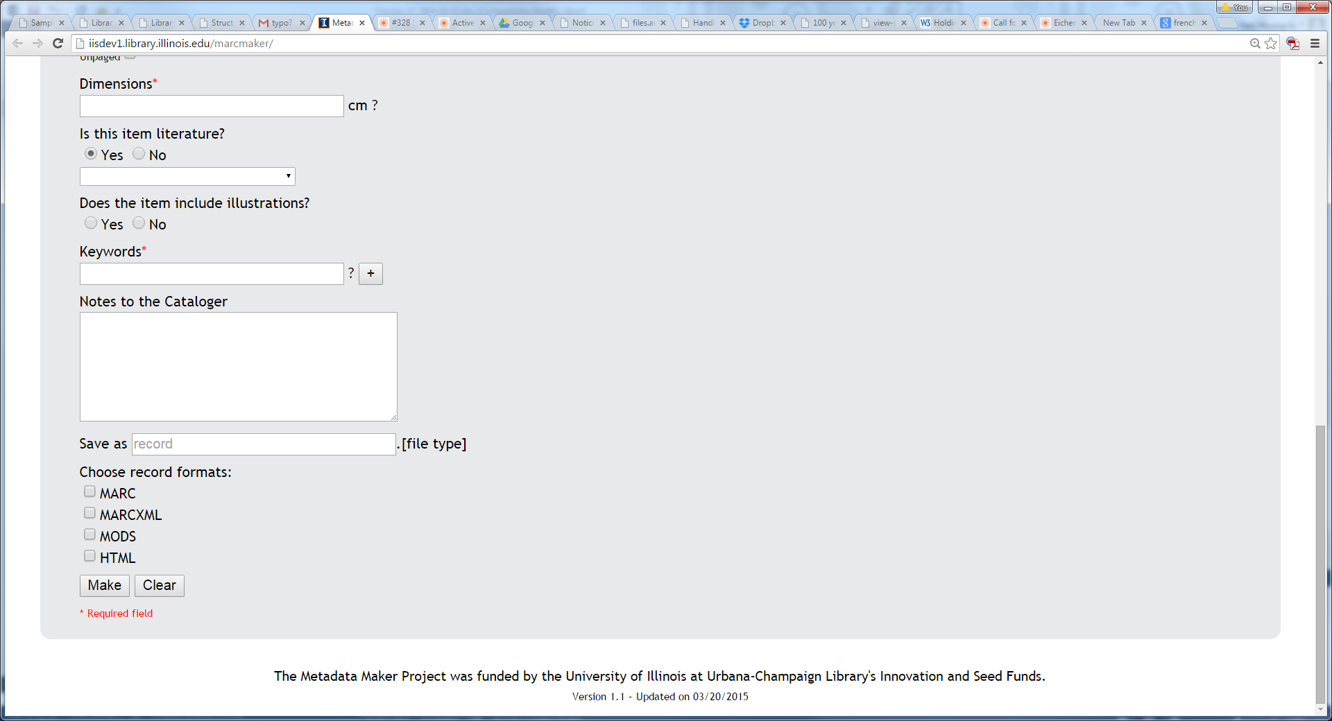

1. **Browser**

The application works best in Chrome and FireFox.

1. **Open Source**

All source codes are available from here, <https://github.com/dkudeki/metadata-maker>, as an open source, so anyone can use and modify as needed.

1. **Questions or Comments**

Please contact [mhan3@illinois.edu](mailto:mhan3@illinois.edu) for any questions or comments.

2015-04-09 MJ Han